**Task 6-GPT**

**Styling Text and Fonts in CSS**

CSS provides various properties to style text and fonts, allowing you to control the appearance of your text in web pages. Key properties include:

* **font-family**: Specifies the font used for text.
* **font-size**: Sets the size of the font.
* **font-weight**: Defines the thickness of the text (e.g., normal, bold).
* **text-align**: Aligns the text within its container (e.g., left, center, right).

**Example HTML Document**

Here's an example that demonstrates these text properties:

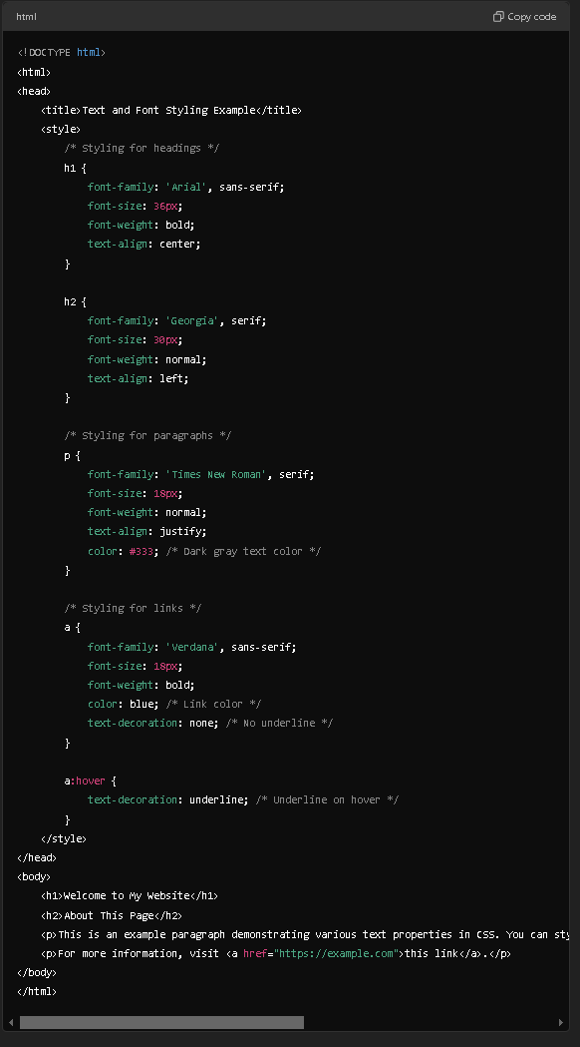

**Result**

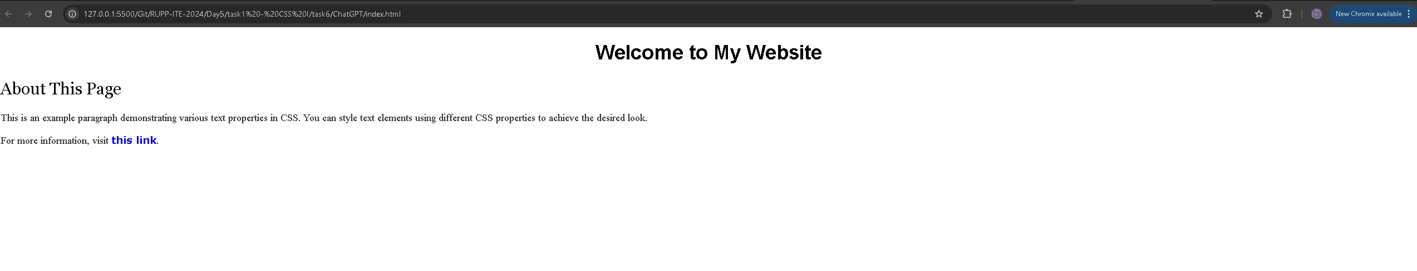

**Explanation of CSS Properties**

1. **h1 Selector**:
   * **font-family**: Uses Arial, falling back to sans-serif if unavailable.
   * **font-size**: Sets the font size to 36 pixels.
   * **font-weight**: Makes the text bold.
   * **text-align**: Centers the heading.
2. **h2 Selector**:
   * **font-family**: Uses Georgia, with serif as a fallback.
   * **font-size**: Sets the size to 30 pixels.
   * **font-weight**: Keeps the text normal (not bold).
   * **text-align**: Aligns the heading to the left.
3. **p Selector**:
   * **font-family**: Uses Times New Roman, with serif as fallback.
   * **font-size**: Sets the font size to 18 pixels.
   * **font-weight**: Normal weight for the text.
   * **text-align**: Justifies the paragraph text.
   * **color**: Dark gray text color.
4. **a Selector**:
   * **font-family**: Uses Verdana, with sans-serif as fallback.
   * **font-size**: Sets the font size to 18 pixels.
   * **font-weight**: Makes the link text bold.
   * **color**: Sets the link color to blue.
   * **text-decoration**: Removes the underline by default.
5. **a:hover Selector**:
   * **text-decoration**: Adds an underline when the link is hovered over.

This example illustrates how to style different text elements using CSS, showcasing the flexibility of font properties to create visually appealing web pages.